***Ice Data from Mary Lake Ontario***

Data gathered for the Mary Lake Assn. by Patch Laferriere  
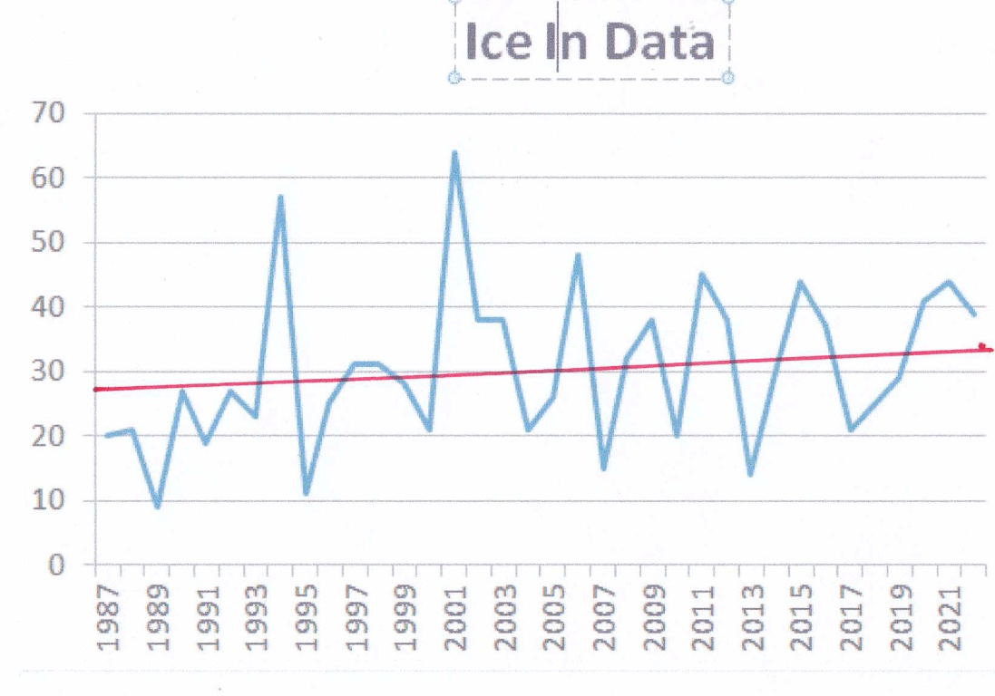

Graphs prepared by Ryan Kidd

The base line for the **Ice In** graph is December 1 and the base line for the **Ice Out** date is April 1. The days after those dates appear on the left side of the graphs.

