**In Response to an initiative of The Mary Lake Association on Sewage, Algae and other lake related issues the following report was prepared to address the Algae Issue. The issue will be discussed at our May 4 th Meeting. Should you like to comment on our Algae study, please send your comments to**

[**mail@marylakeassociation.org**](mailto:mail@marylakeassociation.org)

**Mary Lake Environmental Studies - ALGAE**

**Areas of review: Algae in General**

**Local Issues**

**Blue Green Algae**

**Solutions**

**What is Algae?**

The term algae encompasses a diverse group of organisms, but pond and lake owners typically differentiate among three main types. Each type has distinct physical   
characteristics.

**Filamentous algae —** Filamentous algae is a common occurrence in ponds and lakes.  
Also known as pond scum, filamentous algae is typically green in color and prone to   
grow excessively when nutrients such as phosphorous and nitrogen are   
abundant. Specific types of filamentous algae include *Spirogyra*, which is easily   
identified by its bright green color and slimy feel, *Cladophora*, which is also usually   
green but cottony to the touch, and *Pithophora*, which has a coarse texture reminiscent   
of horsehair. Control methods for each variety of filamentous algae are similar. An   
experienced aquatic management professional can help you identify which species are   
present in your lake or pond and suggest an appropriate remediation strategy.

**Planktonic algae —** All lakes have some level of planktonic algae under the surface. At normal levels, they will not be visible or harmful to overall aquatic health or water quality. However, when algae levels are elevated, they can quickly cause an unsightly nuisance bloom that disrupts the pond’s ecosystem. These blooms are typically caused by a combination of a certain water temperature and nutrient level. A heavy planktonic bloom will give a pond or lake that “pea soup” appearance or may look similar to a layer of green or greenish-blue paint being spilled on the surface of the water.

**Macrophytic algae —** Macrophytic algae are complex, multi-celled organisms with a plant-like appearance. Also known as chara, muskweed and stonewort, macrophytic algae are plant-like in appearance, with clearly identifiable stems and leaves. They grow on the bottom of ponds and can become covered in calcium, giving them a gritty, crusty feeling. At normal levels, macrophytic algae are important components of a pond’s ecosystem, providing food and shelter for a variety of fish. However, excessive growth can cause problems. Because they are so unique from other forms of algae, chara require different types of control. Mechanical removal or treatment with an algaecide are common interventions.

**Local Issues**

**The reed beds at the top of the lake**.

These beds are actually rice beds. The beds seem to be under stress as well. They are coming up black in the spring rather than green but turn green later. Part of the problem may be the higher water levels in the spring that submerge the beds. It has also been suggested that the heavy pollen may have an influence.

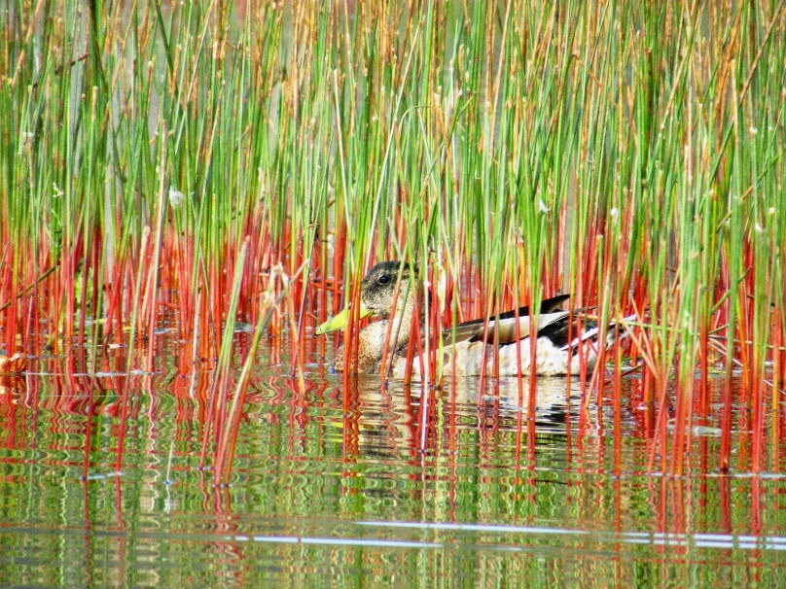

**Early contamination**

There has been no political interest in getting proper testing of the old tannery lands and a full inspection of the over 43 concrete tombs that are buried in the land beside the Federally Protected Muskoka River, according to Peggy Peterson. This issue should have the attention of everyone including our MP and all the Mayors since Huntsville is up river from everyone in Muskoka.

**Blue Green Algae**

Blue-green Algae Blue-green algae, or cyanobacteria, are actually photosynthesizing bacteria, not plants. Blue-green algae are commonly found in lakes and ponds. Some types of blue-green algae produce toxins while others do not. The only way to determine if a sample of blue-green algae contains species capable of producing toxins is to analyze the sample in the lab. Blue-green algae blooms are likely to occur during sunny, calm weather when high concentrations of nutrients are present in water. Fresh blooms may smell like fresh-cut grass, while older blooms may smell like garbage. When the algae die and decompose, toxins may be released in those species that produce them. Symptoms from drinking water contaminated with bluegreen algae include headaches, fever, dizziness, diarrhea, abdominal pain or stomach cramps, sore throat, nausea and/or vomiting. Blue-green algae have several characteristics that enable them to out-compete other species of algae, including: • The ability to adjust their buoyancy so they can float or sink depending on light conditions and nutrient supply • Using nitrogen fixation to maintain high rates of growth when other forms of nitrogen are depleted • They are less favoured by predators than green algae because they produce chemicals that make them ‘taste bad’

**Picture of Blue Green Algae**

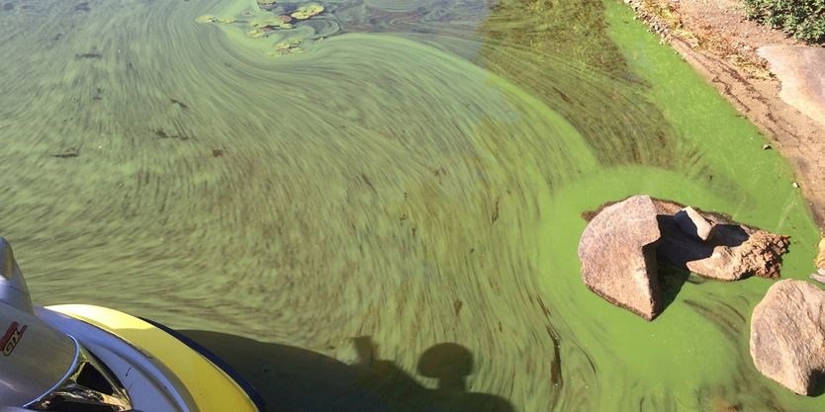

**Three Mile Lake**

Three Mile Lake, Township of Muskoka Lakes An example of what happens when things go bad occurred in the fall of 2005 when a blue-green algae bloom covered Three Mile Lake. This was the first known bluegreen algae bloom in Muskoka.

Several factors contributed to the occurrence of this bloom, including unusual weather. The Three Mile Lake watershed is one of the few in Muskoka with a large agricultural community. The lake is also heavily developed and has been experiencing an increase in phosphorus inputs.

**If it's near your water supply**

Home treatment systems may not remove toxins and can get easily overwhelmed or clogged" so they should not be relied on. Do not boil the water, or manually treat the water with chlorine or other disinf-ectants, as this could increase the toxin levels.

**If you:** .

-are connected to a municipal water supply system or other central water treatment and distribution system, you can continue to use the water normally unless notified otherwise by the system operator or the local health unit .

-have your own well supply with a groundwater source (not including shore wells or infiltration galleries), or yoll receive trucked water in cisterns, you can also continue to use the water normally .

-get your water supply from your own surf-ace water intake in the area of a bloom, you should consider an alternate source of drinking water for the duration of the bloom

**Contact the local Health Department**

**Solutions**

**Kawartha Lakes Solution**

“The whole industry is going the way of aeration,” says DeMarco.

“This method pumps oxygen into the bottom of a lake, for example, along with our natural vegetable-based enzymes which consume the muck which coats everything and provides a breeding ground for these unwanted plants.

"Bugs eat the enzymes and fish eat the bugs. It’s a completely safe, environmentally-friendly long-term solution, and the final result is we are able to naturally turn swamps into swimming pools.”

Keung’s company, Aqua Weed Harvesting, specializes in controlling the vegetation growth of lakes connected to the Trent-Severn Waterway.

**Virginia USA Solution**

[**https://www.pubs.ext.vt.edu/420/420-251/420-251.html**](https://www.pubs.ext.vt.edu/420/420-251/420-251.html)

**Ontario’s 12 Point Plan of Blue Green Algae**

[**https://www.ontario.ca/page/blue-green-algae**](https://www.ontario.ca/page/blue-green-algae)

**Under the following Headings**

**1.Communicating, engaging and working with partners**

**2.Reducing nutrients**

**3.Protecting our drinking water sources**

**4.Science and innovation**

**5.Support**

**6.Legislation and regulatory tools**

**7.Water quality standards and guidelines**

**8.Monitor**

**9.Public health**

**10.Contingency plans**

**11.Analytical laboratory services**

**12.Drinking water system courses**