Narrative for the Mary Lake Boat Tour

The Locks
Water was the main method of transportation in Muskoka before 1900. The network of lakes around Huntsville facilitated this. Since Port Sydney was an important centre to open up the lands to the north, the locks here were built very early in the settlement of the region. The first locks were built here between 1873 and 1877. They were built of logs and leaked badly but did the job.
Cottrill’s Mill
The height of land here also was used to produce the power for a sawmill. You can see the swing bridge which connected the mill to the mainland. The mill which stood on the little Island in the middle of the river was taken over by Frank Cottrill in 1904 and operated until 1957 when it was torn down by the Ministry of Natural Resource. The Cottrills still live in the area and Cottrill’s Bay is at the top of Mary Lake. Frank learned his trade from Sydney Smith after whom Port Sydney is named. In those early days there were 7 mills between here and the bottom of Mary Lake. Between 1870 and 1925 with the encouragement of the government, that wanted the pine trees and the work of the settlers, took off the fine stands of oak, beech, walnut as well as the pine and tamarak. The settlers worked at their farms during the summer and then the men went to the lumber camps for the winter.
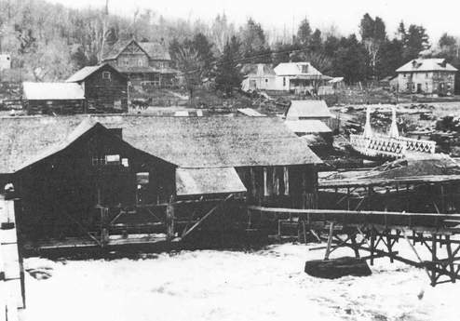
The Pheobe
On August 22 1949 the last of the steamships like the Phoebe that plied these waters sailed down the river where you are going. It ended a great period that saw many steamships like the Northern which was the first side wheeler out of Port Sydney, the Ramona, the Joe and the many ships called Gem. Steamships had been supplanted by road and rail.
Back to the Phoebe. It was 48 feet long and had sailed as a tour boat on Lake Muskoka for many years before being brought to these waters. You may have noticed the large boathouse just before the bridge you just passed under. That was the boathouse for the Phoebe. On that day in 1949 she went through the locks that had been closed because of deterioration caused by years of heavy use to take logs through them. The Phoebe grounded on a gravel bar south of the locks and only through the efforts of the crowd on ropes was she able to continue her trip to Port Sydney. There she was taken by truck to the museum at Kingston where she is located today.
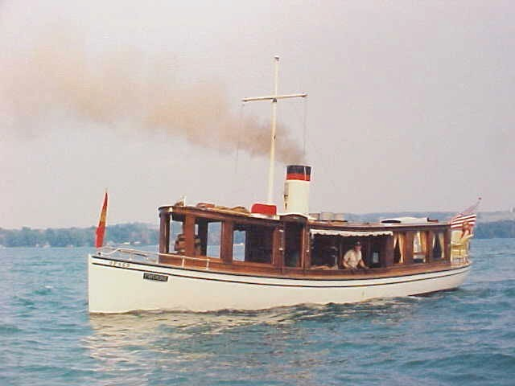

The Rock (at Camp Widjiitiwin)
The logs destined for Olan’s Mill, which is located just down the river from here, were brought out of the woods and piled up on the hillside to your left. The pile was called the High Dump. In the spring they would be rolled down the hill into the water. One spring their progress was halted by that large rock. The men eventually blasted the rock out of the road, but two men were killed in freeing the log jam. The rock stands as mute testimony to the two men who died there.
Arcadia
To your right is Arcadia Lodge. It was operated by the Seeley Family from the 1890’s until it was purchased by the Wallace family if 1945. Most of the guests came down from Huntsville by boat. Once lumbering faded, people began to discover the beauty of the lakes and the clean air.
Compared to the polluted conditions of the cities and the threat of tuberculosis the lakes of Muskoka became an oasis. Mary Lake attracted many tourists after the turn of the century. Today few of the 25 lodges and tourist homes remain, but in their heyday they really thrived.
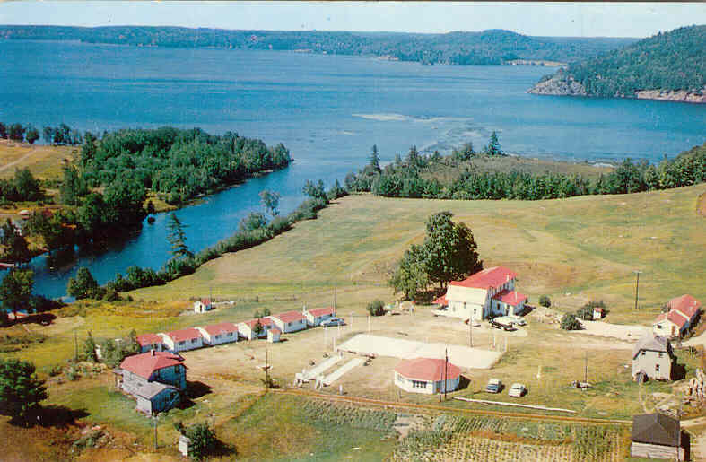
Muskoka Bible Centre
The Bible Centre on your left is a huge operation. Originally the land was owed by the Olan Family who ran a shingle mill . By 1927 the supply of trees for shingles ran out and the demand lessened so the site became a tourist camp owned by Alfred Oland and his wife Grace Hood. Unfortunately due to bad timing, the depression doomed the Breezy Point camp. By 1930 Pastor Dick Holliday bought the 117 acres for use by young Baptists. In those early days the girls were housed in five cabins along the river which were called “Spinsters Row” or ‘No Man’s Land” and the boys were housed in the barn. From this early rough start the camp has been turned into a multi- million dollar operation.
Gryffin Lodge Area
The Lawrences
Ahead is called Lawrence Island. The Lawrence’s owned the land here and farmed it after settling here in 1869. They came from the Scilly Islands off the southwest corner of England. The Lawrences had a large family and fitted right into the society on the lake. I mentioned how people escaped from the grimy southern cities and came to the pristine lake to also escape tuberculosis. During the long winters a social whirl existed. Dances at the Lawrence household seen on your right would last until dawn and the people would then start the long walk on the ice down the lake to Port Sydney. In 1947 the farm house was sold to Jan Ostrofsky who turned it into a lodge named after his family symbol…and so it became Gryffin Lodge.
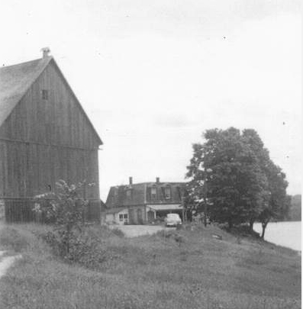

The Ropers
The second bay along this shore is where the Coleridge Roper settled. He bought most of the land along the west side of the lake. Coleridge, a graduate of King’s College in England, travelled to South Africa in 1872 where he became friends with Cecil Rhodes of the diamond mines at Kimberly and after whom Rhodesia was named. Returning to North American he stayed in Nebraska before he moved to Mary Lake in 1876. There he married Alice Ladell a local girl and had five children. With his background he fitted right in with the society on Mary Lake. Among other things he headed up cricket and curling clubs in Port Sydney, Bracebridge and Orillia. In later life he and many others from Port Sydney moved west to the drier climate at Bittern Lake in Alberta to avoid tuberculosis.
Grunwald
Gruwald Lodge was located where you see the grey cottage. William Gall came from Waterloo and got his experience with lodges by managing some of the great lodges on the lower Muskoka Lakes. By 1901 he and his family had established their home on Rowanwood bay. In the October 18th edition of the 1901 Huntsville Forrester it was reported that William Gall would build a large summer resort on Rowanwood Bay that would accommodate 100 guests. They would be transported by boat from the Grand Trunk Rail Station in Huntsville. By building late in the fall he was able to get help before the men would be hired to work at the lumber camps in the winter. The original name of Greenwood was changed to Grunwald which meant the same thing but would attract Europeans who would see this experience as an adventure offered by the new world. The Forrester reported that “Wide verandas have been placed on the side facing the lake. The superior dining room is situated on the ground floor and is large enough to accommodate 100 people. The bed rooms are large and airy while the smoking rooms and parlours are comfort par excellence.” Grunwald was a great success, so much so that a year later an addition had to be made. The rate was between eight and fourteen dollars per week.
Like many of the great resorts of Muskoka, Grunwald burned to the ground. On November 21 1918 at the end of World War 1, in 1918, it was gone. Because it burned so close to Armistice Day and because of the name Grunwald, there was a rumour around the lake that arson was involved. This was clearly false because there never was any European involvement in the ownership of the lodge, but the rumour still persisted.
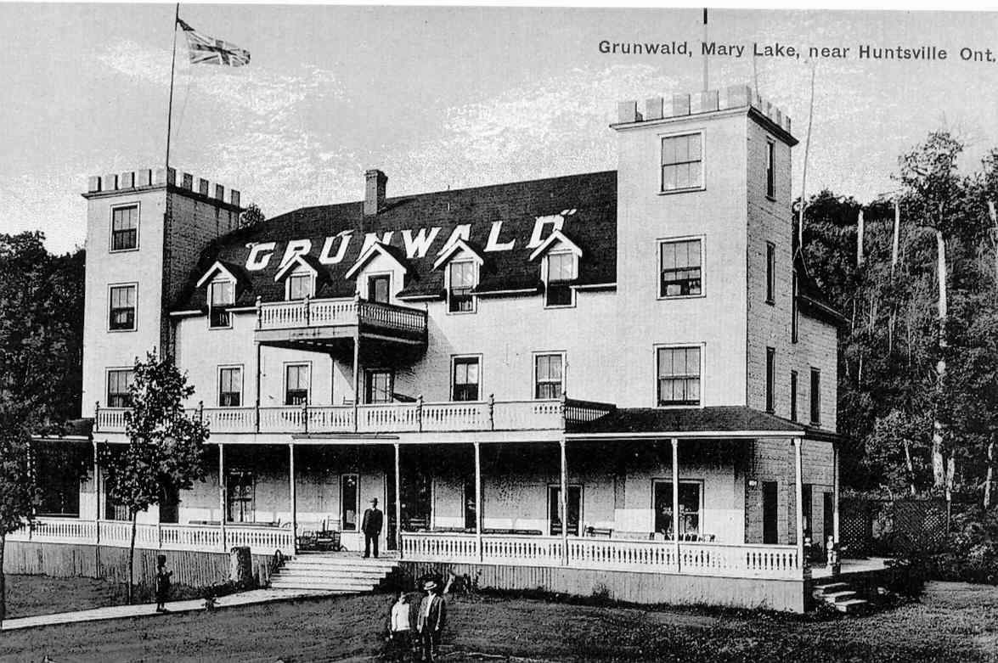

Glenokawa Camp
Glen Allen was a pianist, an artist, an actor, a dancer and a conversationalist. He was larger than life and charmed the listener. Born in 1904, in 1928 he joined the famous Dumbell Troupe after WW 1 during a revival of the troup in England. For many soldiers in the mud filled deadly trenches the Dumbell Troup had been a bright moment of laughter and song as they made fun of army life, did ribald impersonations and sang risqué songs.
Glen decided to bring his energy and enthusiasm to his own camp for boys on Mary Lake in 1932….and so camp Glenokawa was born. From then until its demise in 1958, hundreds of boys came for two weeks to learn canoeing, swimming archery, boxing, the arts and drama. They also learned about the Goldern Rules, table manners, sex and held debates about God. The graduates of the camp went on to successful careers. One became the Director of the National Art Gallery. The high point of each summer was the August Holiday when the whole camp participated in the annual regatta and did a show at the Community Hall. This show was called the “Annual Riot” and was noted for a show like the original Dumbell Shows.
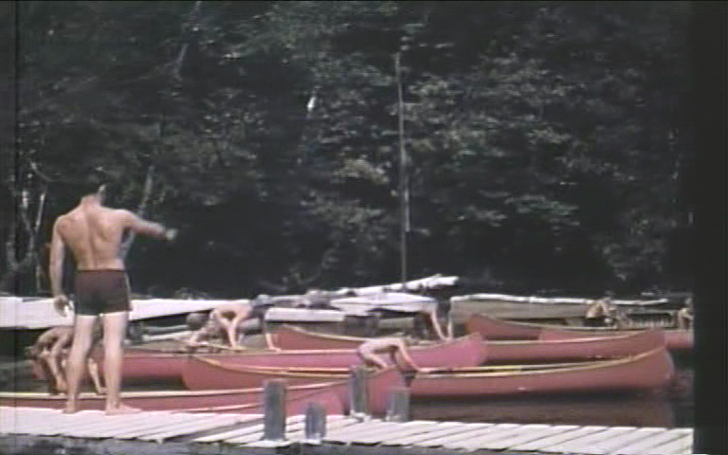

Port Sydney
Port Sydney started in the late 1860’s and got a real boost when Sydney Smith arrived in the early 1870’s. He bought the land upon which most of the village sits and started the saw mill and grist mill that fuelled the economy of the village in early days. The village was a port where steamships departed regularly with goods and people destined for the upper lakes. Port Sydney was a trans-shipping point from the road and later rail head in Utterson two miles to the west. When the lumber economy faded around 1900 the beauty of the setting attracted tourists who still come to Mary Lake.

Bellview Hotel
Bellview Hotel was built in 1904 and has run in various forms ever since. It was run by the Clarke family. Tourists from the Lake of Bays would arrive on the Algonquin and Ramona steamships. The ships would blow their whistles when they arrived at the top of the lake as a signal to start the potatoes on the stove so that dinner would be ready when the tourists arrived at the hotel. 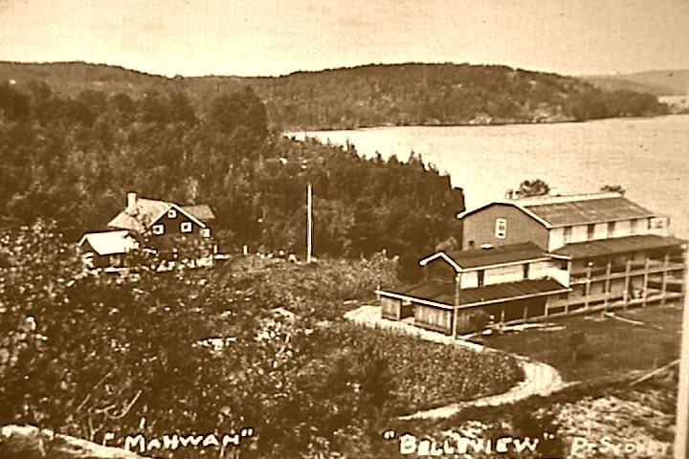

Ladell’s Store
The large white building at the corner of the lake was a store operated by the Ladell’s and later by the Hoth’s and the Clarke’s. These were the families along with the Smiths, the Jenners and the Thoms that formed the core of the fledgling community. They intermarried and had parties, dances and literary soirees over those early years. As one oldtimer told me …”you didn’t marry anyone more than two miles away because that was walking distance that you had to return from before dark.”
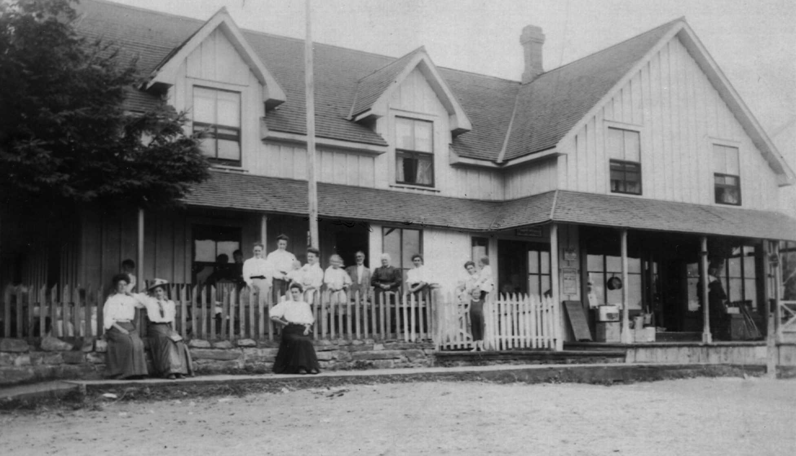
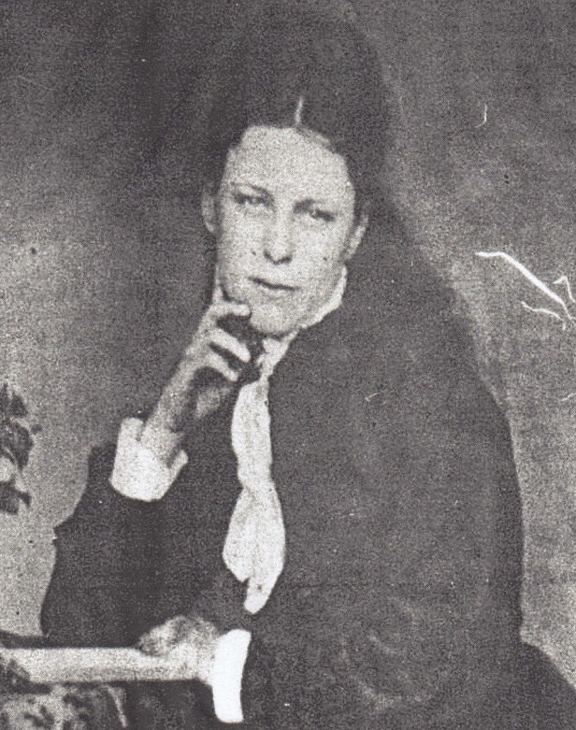
Emma Ladell
Along the front of Port Sydney
Constant fires burning the brush from land clearing were a feature of life. One such fire got out of hand and the people of the little town were forced onto the lake. Many of the people could not swim and were also carrying their children. The results of that fire meant that pictures of the town showed the islands clear of trees.
The second house east of Ladell’s store was where William and Emma Clarke lived. She bore him 12 children of whom all but three were girls. These girls married into all the local families and it is why today nearly everyone in Port Sydney is related to the Clarkes.
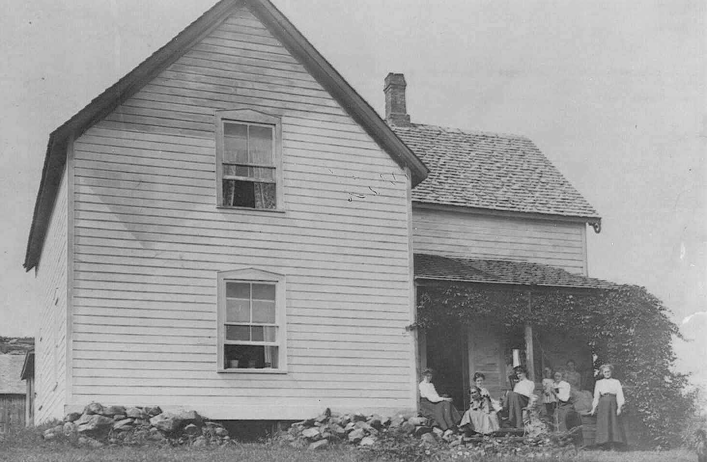
At the east end of the beach was a shingle mill. It closed in 1896 but the water still smells of cedar.
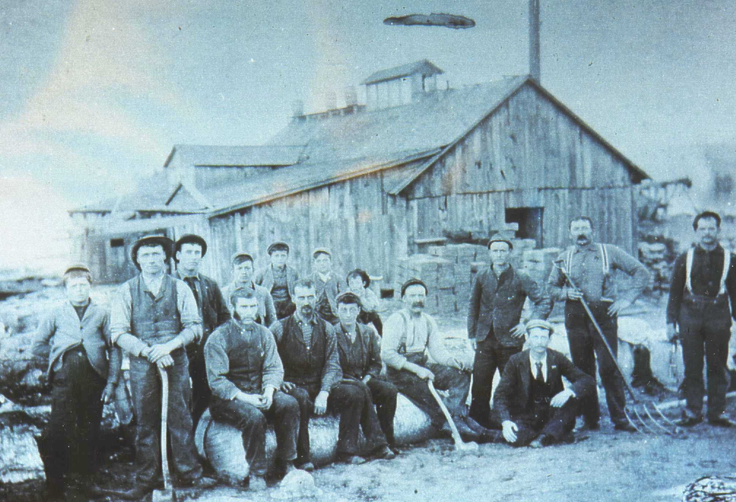
Down the River
The Anglican Church The original church was built in 1973. It burned down in 2001 and was subsequently rebuilt along the lines of the original church.
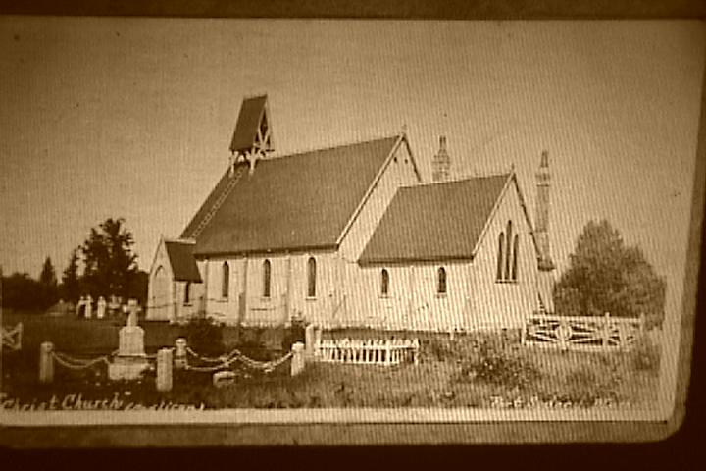
The Cheese Dock It was here that farmers brought their milk in the early 1900’s to be made into cheese at a cheese factory just behind it. It also served as the village hall until 1928 when the present hall was built.
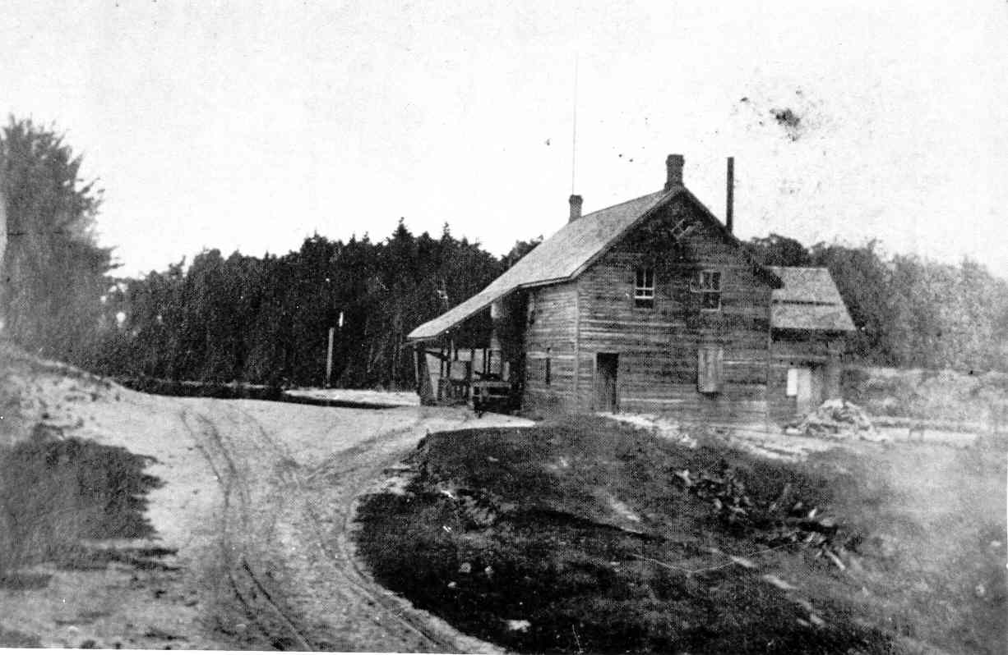The
Dam and Mills This was the centre of the town from 1870 until 1900. Looking at the picture you can see the grist mill in the near ground and then the sawmill. The Algonquin is the side wheel steamer seen tied up near the sluice way where the water entered to power the mills. Sydney Smith’s house and barn can be seen in the background. The Algonquin was built on the lawn to the left of the house
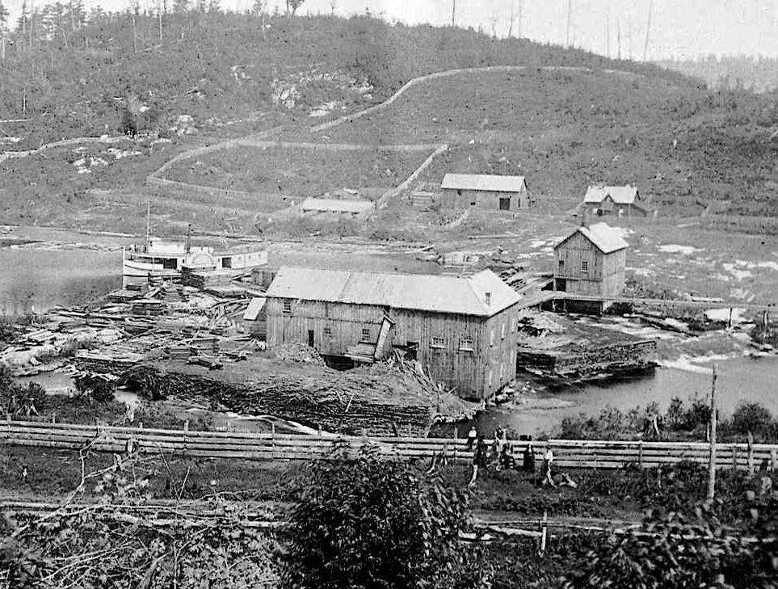
The Moodies
The three cottages on your right were owned by the Moodies. They built them in the 1930’s. The father operated knitting mills in Hamilton, although he probably was best known for bringing hydro to Hamilton. Stelco and Westinghouse were attracted by the cheap power making Hamilton the industrial centre it is today.
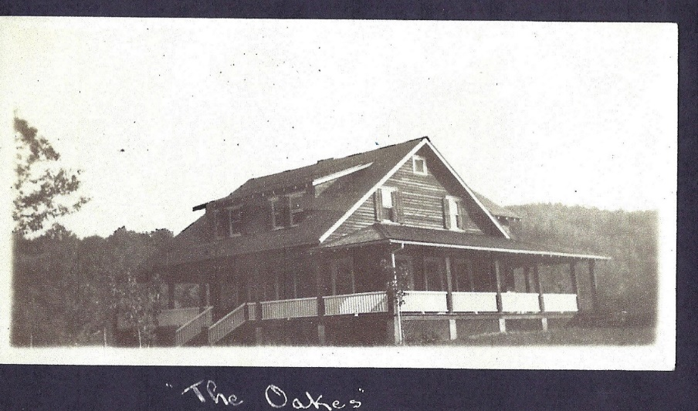

Clyffe House
The Jenners were one of the early families to settle in Port Sydney in 1869. James Jenner worked hard and bought additional land along the lake. His son saw the possibilities for development and by the early 1800’s had constructed the three story building with 22 guest rooms. He also built on your right the two story Dance Hall and Boat house. The three story annex on your left, with a further 22 bed rooms, was completed in 1905.
The Jenners provided three meals a day with double occupancy for between $16 and $20 a week in 1920. They also provided a full range of activities including dancing, tennis, canoeing and rowing, horseback riding concerts and steamship rides on the Joe and the Gem. Doris and Kay Jenner continued to provide full dinners from the 50’s until Dave Scott took over and made it into a housekeeping resort with 80% repeat business. The emphasis continued to be on maintaining the repeat family business. Clyffe House is the oldest resort in Muskoka that has been continually run by the same family since its inception.
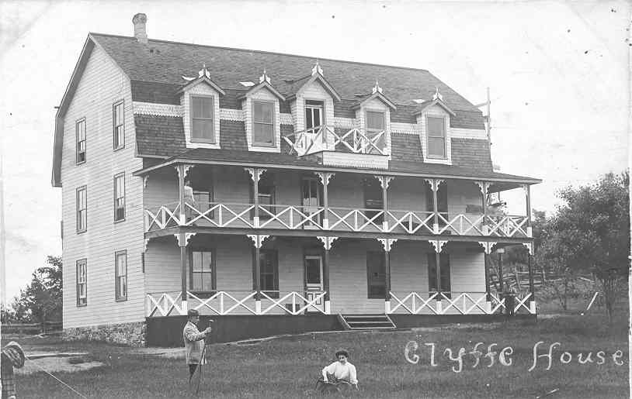
Muskoka Lodge
On your right was the location of Muskoka Lodge which operated here in the 1930’s. The dining room would seat 200 and the staff dining room would seat 60 chambermaids, cooks, mechanics, waterfront staff, grounds keepers, chore boys, laundry staff, dishwashers and kitchen help. It catered primarily to a Jewish clientele from the northeast United States and Toronto where they were received without the prejudice that was so common in those days.
The Ginsberg’s and Mr. Handler brought in top entertainment including some of the stars from the Ed Sullivan show.
By the 1960’s the Jewish clientele were no longer coming to the resort and it was taken over by Browndale Camps who provided a home for emotionally disturbed youth.
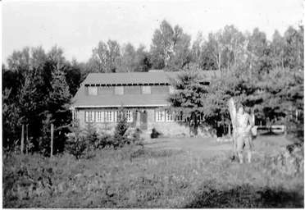
Captain Cock
The last story in this narrative is the story of Captain Cock and Deadman’s Island. The Captain had been a ship captain on the Great Lakes and in 1869 at the age of 62 he decided to settle on Mary Lake. He married the 22 year old daughter of Emma Ladell and they had six daughters. Apparently he had to marry the daughter and when he was rowed by the daughters to the dock for groceries, he would leave them in the boat and walk to Utterson rather than walking across the road and face the wrath of his mother in law
They lived on the island to your right which was attached to the mainland by a causeway. In 1889 he died and was buried on the island. They say his ghost haunts the island and scares the kids from the camp across the way. The Island was renamed from Cock Island to Deadman’s Island by the camp people.
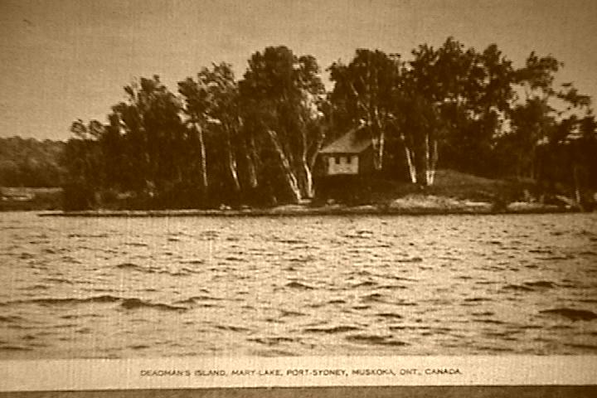
___________________________________________________________________________
If you would like a copy of the book from which these stories are taken, it can be ordered from Trafford Publishing. The book is called “These Memories I Leave to You”
Ryan Kidd
Location of the places above.
https://binged.it/2Aqrryz
https://binged.it/2Avsyga

